**TFL Operations Manager Process**

* Operations Manager will login to Observation model-driven app, and will be able to view below Operations Manager Dashboard as follows
  + 1st tile for Safety Critical Observations which will list out all the active observations that are tagged as High for Is Safety Critical?.
  + 2nd tile which has two views to display all active and inactive observations for manager to view
    - Inactive observations have the linked case lookup available for the manager to directly navigate to the case.
  + 3rd tile that lists out the active cases that are linked to observations.
  + 4th tile that lists out the resolved cases that are linked to observations.

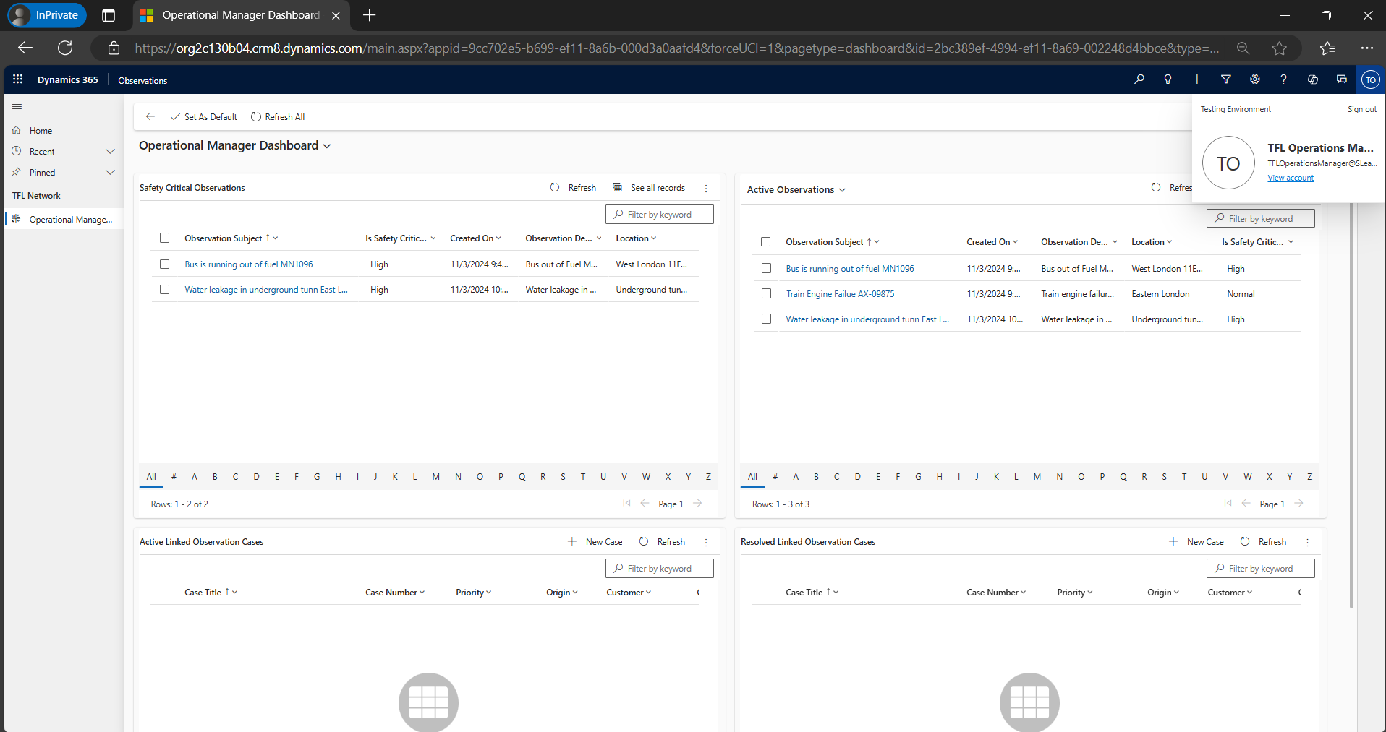

* When the user navigates to the observation record, they can see below tabs.
  + General Tab – Tab that contains the observation information like subject, location, description, and safety critical.
  + Timeline – Tab that will have all the activities linked to the observation like notes with attachments(images), email activity and other activities.
  + Record Log – Tab that contains the record information like created by, created on, modified by, modified on, Linked Case, Status fields.

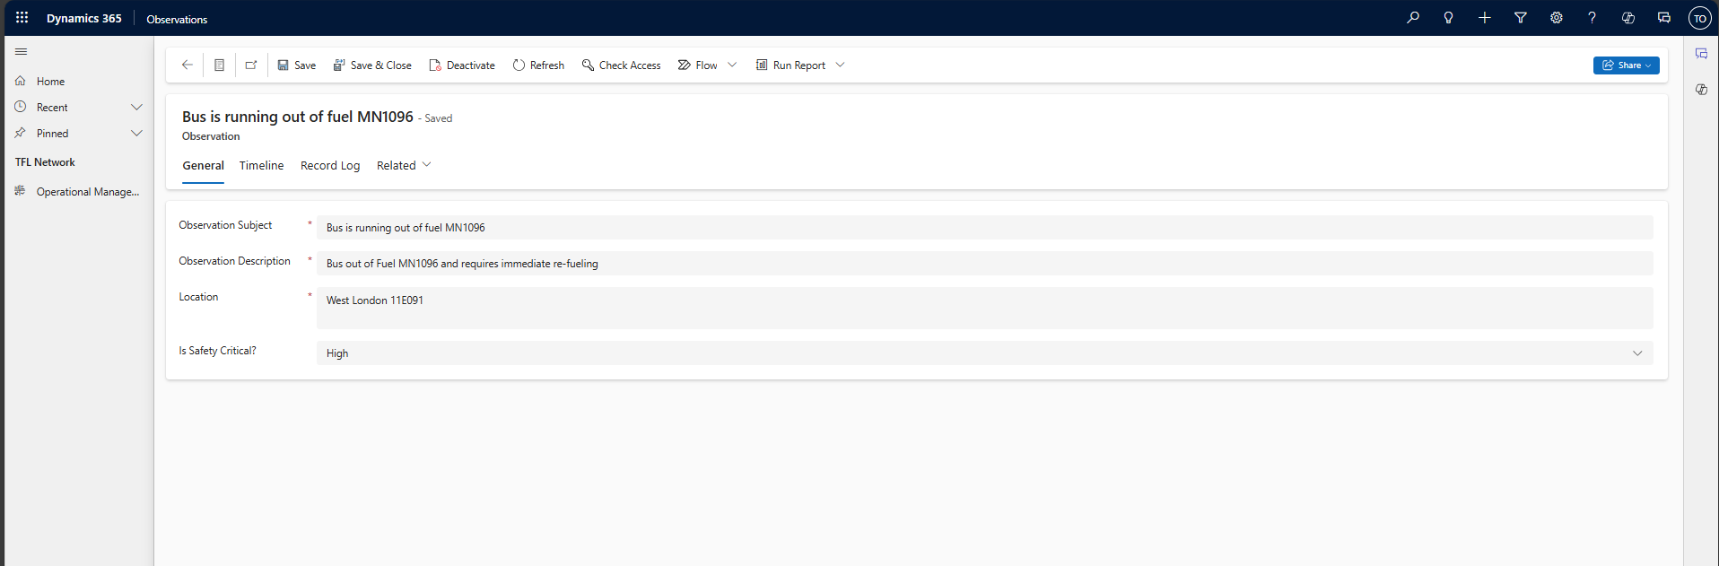

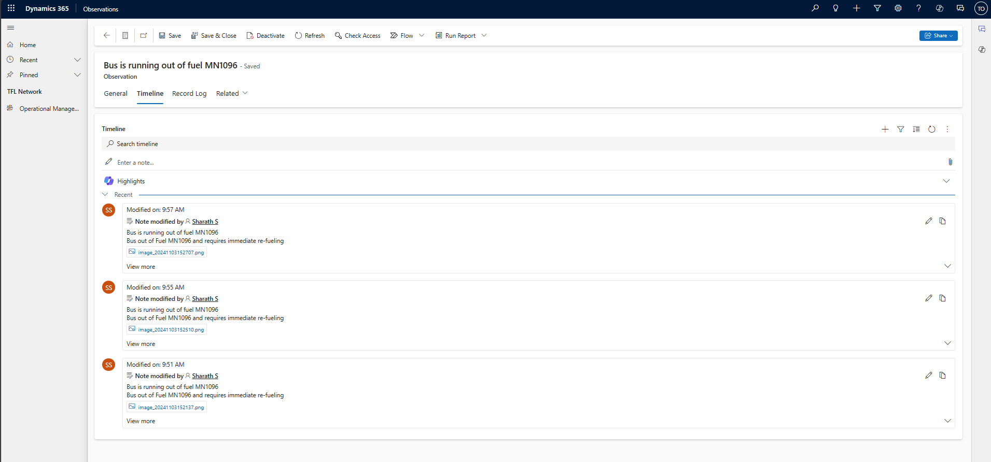

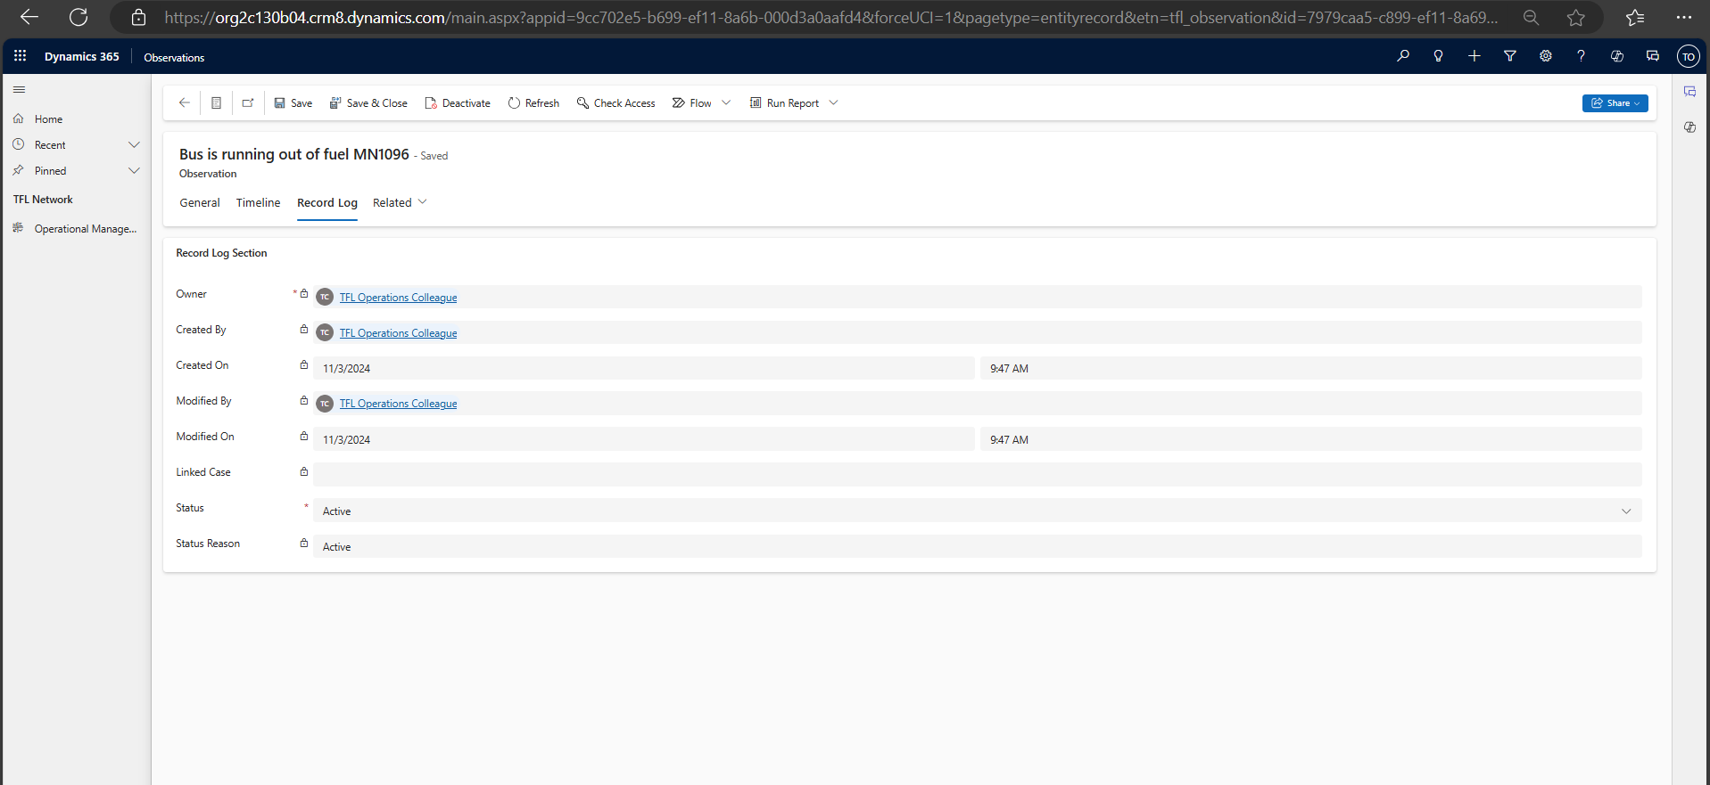

* Image attachment contains the overlay of TFL roundel on each image created by the operational colleague.

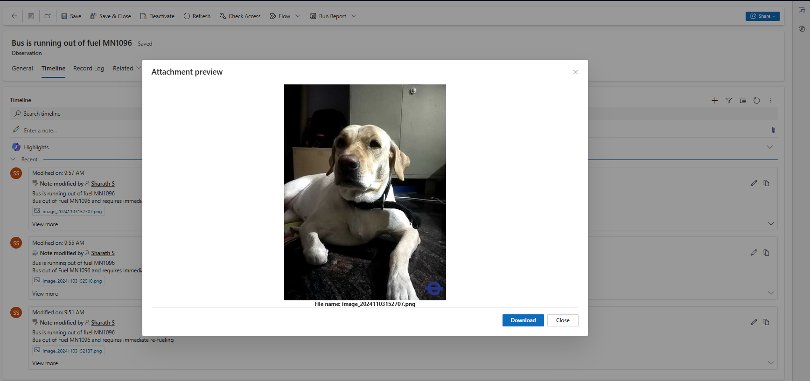

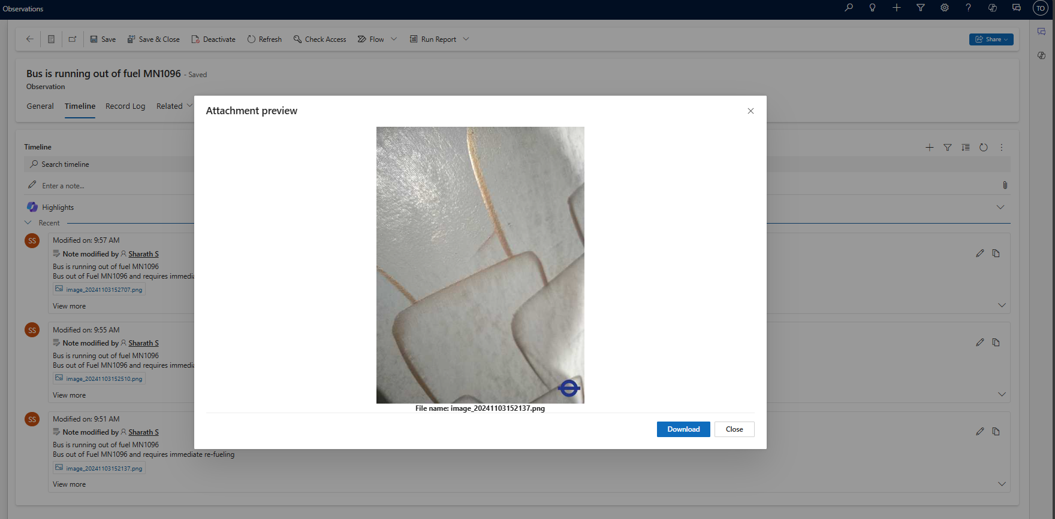

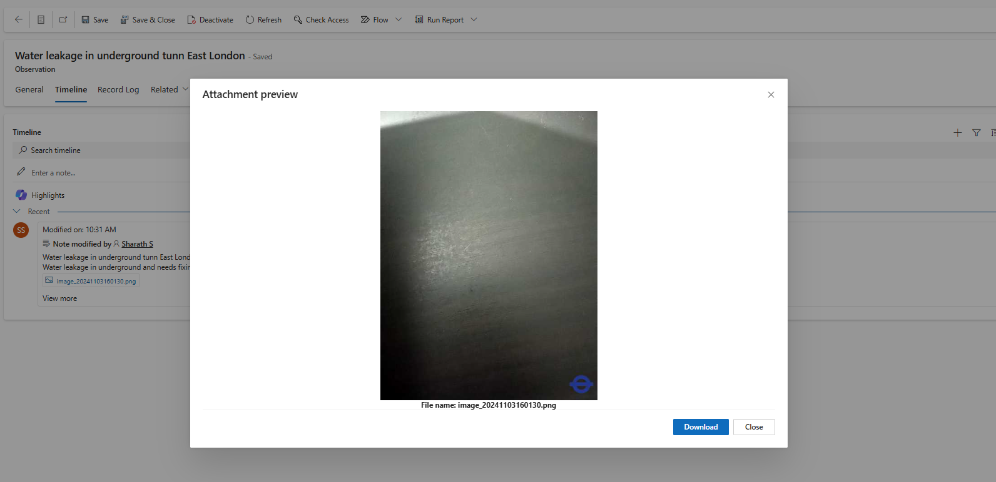

* Operations Manager can convert the observation to a Case by triggering the below flow(Flow is designed to pickup one request at a time and will not create duplicate cases).

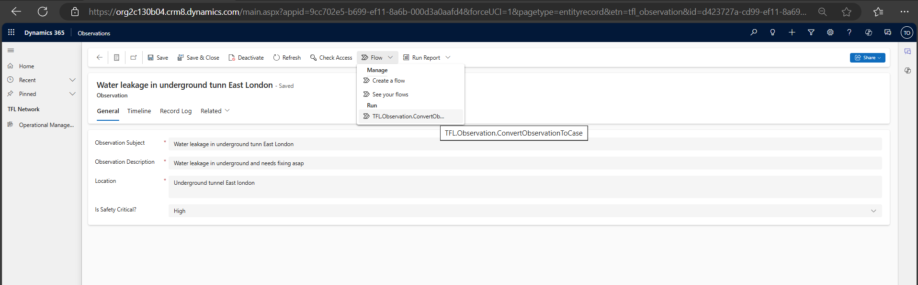

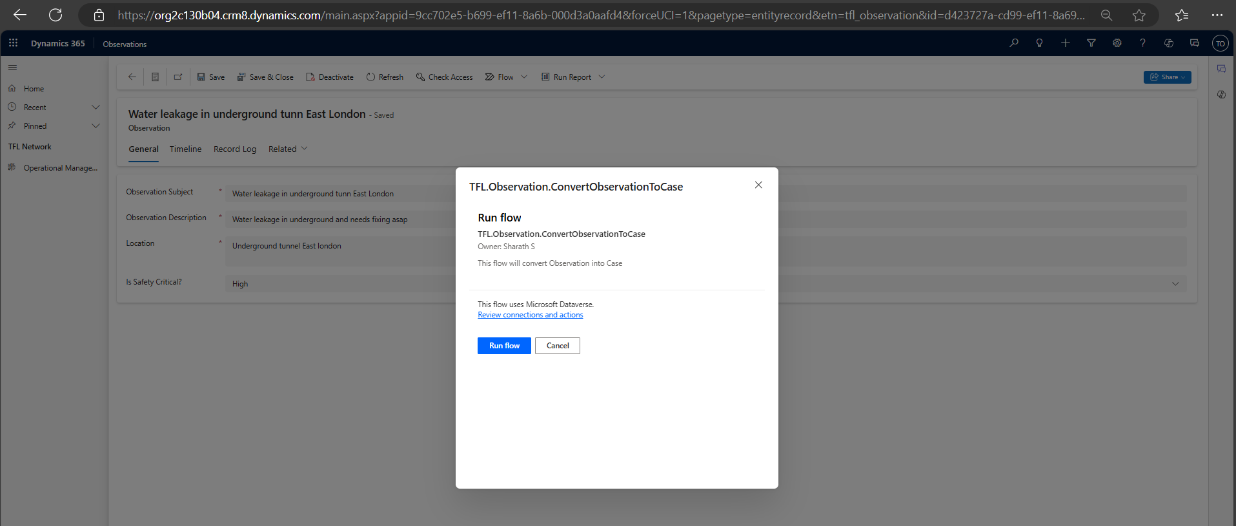

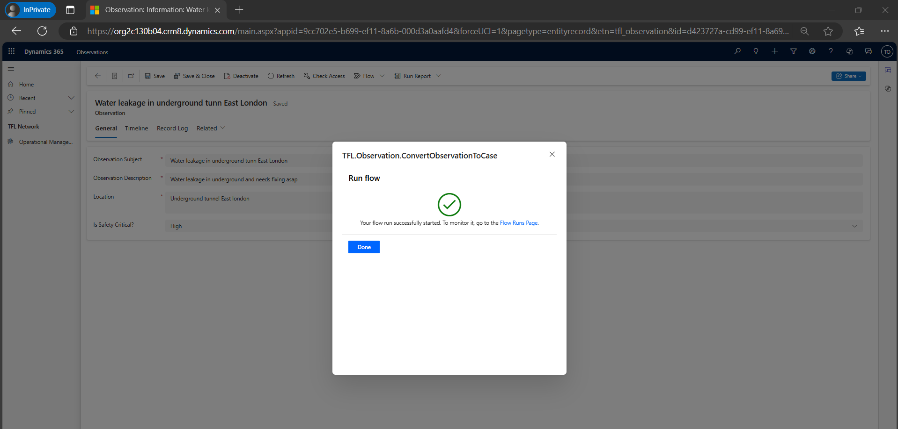

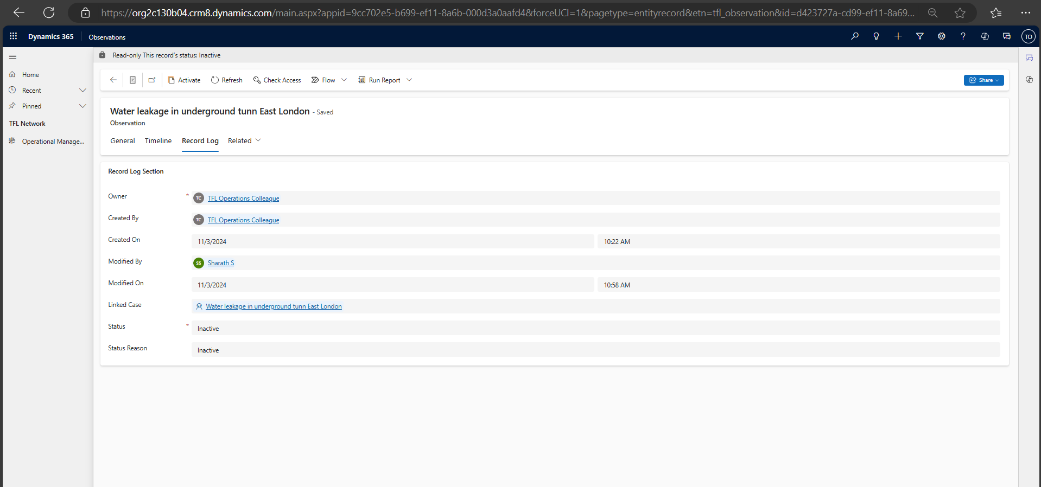

* Once the observation is converted to a Case, the observation will be deactivated and case will be linked and email will be triggered to Operations colleague that created the observation as below.

